LESSON PLAN 8 – Integrated skills – Reading and Speaking November 30, 2015

Teacher’s Name: Larry Fedorowick

Level: IELTS – Reading and Speaking

Duration: 50-60 minutes

Lesson Aims:

- To analyze a an authentic text and identify elements such as: topic, main idea, most interesting details
- To practice paraphrasing (both verbally and in writing)
- To identify, deal and practice with new vocabulary
- To practice speaking about current events
- To practice forming opinions
- To develop self-study skills

Lesson Outcomes: Students will analyze, take notes on, and speak about a news article using new vocabulary from the article.

Assumptions The students have a level which allows them to read a standard news article.

Anticpated problems and solutions

- Students may need help in forming opinions. (This is often the case in Vietnam as giving opinions is not encouraged in their school system). Solution. I will give thm examples of what an opinion is and also help them to realize when they may be simply repeating something in the article rather than giving an opinion.

- The students have different levels. Solution: I will choose materials which have different degrees of difficulty. In addition, students will be placed into groups strategically so that weaker students can get assistnce from stronger ones.

Preparation and materials:
The teacher prepares two or three authentic newspaper articles for the class to work with.
Step 1
TIME | 5-10 min
STAGE in the LESSON | Creating interest in the topic
Teacher Activity | The teacher gives out a series of questions for the students to discuss in groups. See below.
Student Activity | Students participate in the discussion
Interactive pattern | T- SSS
Aids | Whiteboard, photocopied cut outs with questions
Questions include:
- How much time do you spend reading?
- What sort of materials do you enjoy reading? (novels, comic books, news articles, etc…)
- Did you enjoy the same kinds of materials when you were younger?
- Do you prefer reading online or with books, newspapers and magazines?
- Do you think young people have good reading skills? Why or why not?
- How can reading be useful when learning IELTS?
Step 2
TIME | 10 min
STAGE in the LESSON | Review of concepts
AIM | - Students need to be sure of the difference between TOPIC and MAIN IDEA.  - Students need to understand what an opinion is
Teacher Activity | The teacher shows the students a series of pictures such as the one given below and asks students to identify the topic and main idea of the pictures. Students should also discuss their opinions of the diagrams.
Student Activity | Students work together to analyze the diagrams
Interactive pattern | S-S-S
Aids | Diagrams shown on the overhead, computer, projector

NOTE: This is a scaffolding exercise designed to set up the analysis of the reading texts.
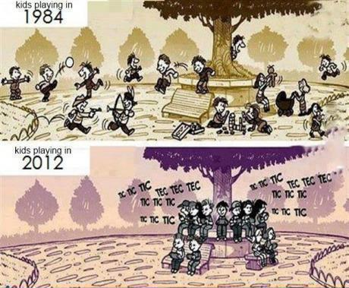
Possible answers:
TOPIC: The diagrams compare the way kids spent their free time in 1984 and in 2012

Main Idea: Kids were much more physically active in 1984 than in 2012

Opinion: Of course, there are many opinions. The teacher needs to help students avoid ideas which just repeat what they see in the diagram, such as “I think kids use electronic devices nowadays”. The teacher needs to allow the students to feel free to give their own thoughts and to see things from different perspectives.
Step 3
TIME | 15 - 20 min
STAGE in the LESSON | Reading, analysis and paraphrasing
Teacher Activity | The teacher divides the students into groups, giving each group a newspaper article. They are told to read it and to fill in the form below. The teacher circulates to give assistance if needed.
Student Activity | Students work together or individually to complete the task
Interactive pattern | S-S-S
Aids | Authentic articles and handout

TOPIC:

MAIN IDEA:

INTERESTING DETAILS: (use paraphrase)

NEW VOCABULARY: (at least 5 new words – electronic devices are permitted to look up new words).

YOUR OPINION:

Note: Students should not be expected to understand every word in the article. The teacher needs to make sure that students are not translating every word they do not understand. However, students should be allowed to use their phones to look up certain words they think could be useful for the next step. The idea is for students to practice distinguishing between topic specific and general academic vocabulary.
Note: the teacher should encourage the students to learn the pronunciation of these words as well as their meanings, using an online source or asking the teacher for guidance. This will be important for the next step.

Step 4
TIME | 10 -20 minutes
STAGE in the LESSON | Speaking
Teacher Activity | The teacher puts students into pairs so that neither of the two has read the same article. The teacher explains the activity to the students. Later the teacher circulates to provide assistance.
Student Activity | The students are required to tell their partners about the article they have just read. They should be encouraged to speak naturally, NOT to read what they had written in the worksheet in the previous step. Therefore, they are given time to prepare before speaking. Also, students should try to use the new vocabulary when speaking.
Interactive pattern | S-S
Aids | none

NOTE: For consolidation purposes, step 4 may be repeated with different pairs. In this case, the class would be extended by about ten minutes.
EXTENTION: Afterward, the teacher should ask students to tell the class what they leanred from their partners
Step 5
TIME | 5- 10 min
STAGE in the LESSON | Reflection
Teacher Activity | The teacher asks students to write in their diary about what they have learned in this class.
Student Activity | Students write the reflections
Interactive pattern | S
Aids | none

Homework: Students are to find their own article, fill out a similar sheer and be prepared to talk about it in class the next day.

